**Covid19 Tracker – Prototyping**

# Introduction

The objective of this project is tracking the deaths, infected people, recovered people due to the Covid-19 virus throughout India and displaying it through a simple website. This would enable anyone from India to see the state-wise data, patient details of those who are affected by the virus.

The following are the software requirements:

1. State-wise data: Indian map using will be displayed using a JavaScript library like Chart.js and when a user hovers on a state, the user will get the details of deaths, covered and infected people in that state.
2. Patient data: Details about infected patients, way of transmission, place will be displayed which helps users to check if there are any infected patients in their area.

# User Interface Design and Prototype

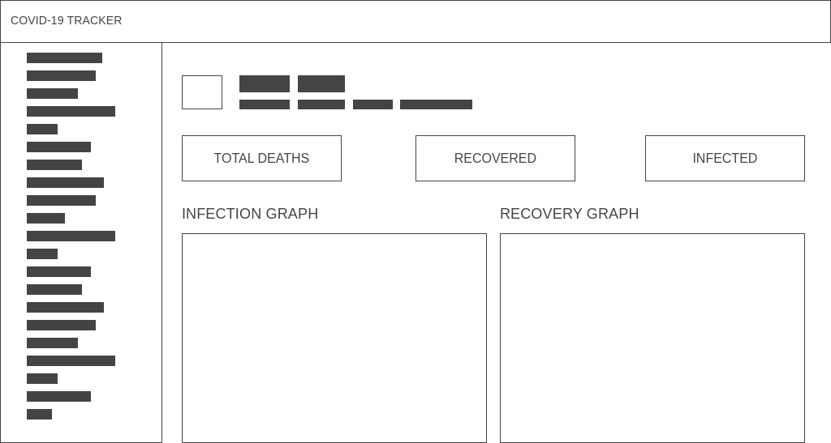

The top will have a navbar and a sidebar on the left.

Options on the sidebar will be All India data, Patient wise Data, State wise Data etc.

This will be a single page application where whenever the user clicks on a nav link, the page will change its content accordingly.

# Navigation Structure

All India data: Home page of the web application

State wise data: An option on the sidebar in the application

Patient data: An option on the sidebar in the application

# References

1. <https://wireframe.cc/pro/pp/eed89da17336128>
2. <https://www.covid19india.org/>